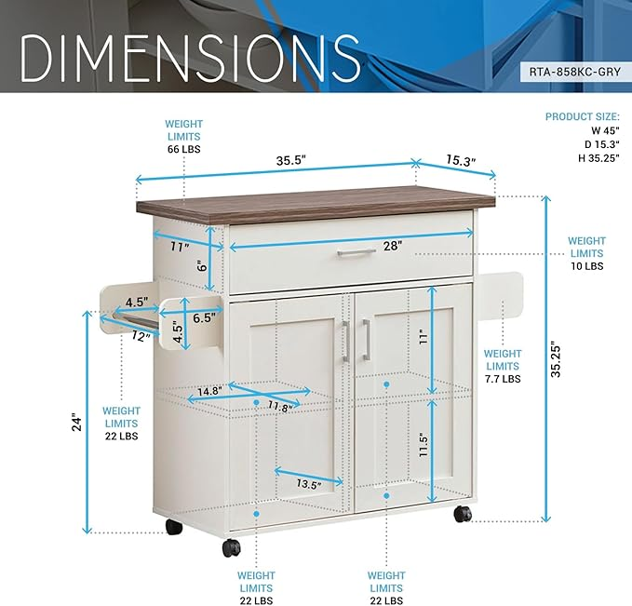

$171

Deluxe Mobile Kitchen Island Cart with Water Resistant Top and Storage Cabinets with Adjustable Shelves – Coffee Bar or Kitchen Cart with Towel Rack and Spice Rack and Locking Wheels